***Database***

**Que :- What do you understand By Database ?**

Ans -> Database is a collection of inter-related data and Management System is a set of programs to store and retrieve those data.

• DBMS stands for Data Base Management System.

• Database is a collection of inter-related data and Management System is a set of programs to store and retrieve those data.

• DBMS is a collection of inter-related data and set of programs to store & access those data in an easy and effective manner.

• For Example, university database organizes the data about students, faculty, and admin staff etc. which helps in efficient retrieval, insertion and deletion of data from it

**Que :- What is Normalization?**

Ans -> Normalization is the process of minimizing redundancy (duplicity) from a relation or set of relations. Redundancy in relation may cause insertion, deletion and updation anomalies. So, it helps to minimize the redundancy in relations.

Most Commonly used normal forms:

● First normal form(1NF)

● Second normal form(2NF)

● Third normal form(3NF)

● Boyce & Codd normal form (BCNF)

**Que : - What is Difference between DBMS and RDBMS?**

|  |  |
| --- | --- |
| **RDBMS** | **DBMS** |
| Data stored is in table format | Data stored is in the file format |
| Multiple data elements are accessible together | Individual access of data elements |
| Data in the form of a table are linked together | No connection between data |
| Data is stored in a large amount | Data stored is a small quantity |
| Here, redundancy of data is reduced with the help of key and indexes in RDBMS  RDBMS supports multiple users | Data redundancy is common  DBMS supports a single user |
| It features multiple layers of security while handling data  The software and hardware requirements are higher  Oracle, SQL Server. | There is only low security while handling data  The software and hardware requirements are low  XML, Microsoft Access. |
|  |  |

**Que :- What do you understand By Data Redundancy?**

Ans -> Data redundancy occurs when the same piece of data is stored in two or more separate places and is a common occurrence in many businesses. As more companies are moving away from siloed data to using a central repository to store information, they are finding that their database is filled with inconsistent duplicates of the same entry. Although it can be challenging to reconcile — or even benefit from — duplicate data entries, understanding how to reduce and track data redundancy efficiently can help mitigate long-term inconsistency issues for your business.

Data redundancy can be found in a database, which is an organized collection of structured data that’s stored by a computer system or the cloud. A retailer may have a database to track the products they stock. If the same product gets entered twice by mistake, data redundancy takes place.

The same retailer may keep customer files in a file storage system. If a customer purchases from the company more than once, their name may be entered multiple times. Duplicate entries of the customer name is considered redundant data.

**Que:- What is DDL Interpreter?**

Ans -> Data Definition Language (DDL) is used to create and modify the structure of objects in a database using predefined commands and a specific syntax. These database objects include tables, sequences, locations, aliases, schemas and indexes

Command Description

➢ CREATE - Creates a new table, a view of a table, or other object in database

➢ ALTER - Modifies an existing database object, such as a table.

➢ DROP - Deletes an entire table, a view of a table or other object in the database

**Que :- What is DML Compiler in SQL?**

Ans -> DML stands for Data Manipulation Language. Tables and formulas are helpful when communicating with data stored up to a point in a database through SQL, but a time comes when we actually want to execute some fairly complicated data interactions. We will also need the Data Manipulation Language in that situation.

DML is a way to inform a database precisely what we want it to do by conversing in a manner that it has been built to comprehend from the scratch. When it comes to interacting within existing data, whether adding, moving, or deleting data, it provides a convenient way to do so.

Data manipulation includes introducing data into tables, altering the table’s data and deleting the data from the table.

**Que:- What is SQL Key Constraints writing an Example of SQL Key Constraints**

Ans -> SQL constraints are used to specify rules for the data in a table.

Constraints are used to limit the type of data that can go into a table. This ensures the accuracy and reliability of the data in the table. If there is any violation between the constraint and the data action, the action is aborted.

The following constraints are commonly used in SQL:

• NOT NULL - Ensures that a column cannot have a NULL value

• UNIQUE - Ensures that all values in a column are different

• PRIMARY KEY - A combination of a NOT NULL and UNIQUE. Uniquely identifies each row in a table

• FOREIGN KEY - Prevents actions that would destroy links between tables

• CHECK - Ensures that the values in a column satisfies a specific condition

• DEFAULT - Sets a default value for a column if no value is specified

•

• CREATE TABLE Student

• (

• ID int(6) NOT NULL UNIQUE,

• NAME varchar(10),

• ADDRESS varchar(20),

• PRIMARY KEY(ID)

• );

**Que :- What is save Point? How to create a save Point write a Query?**

Ans -> A SAVEPOINT is a point in a transaction when you can roll the transaction back to a certain point without rolling back the entire transaction.

The syntax for a SAVEPOINT command is as shown below.

SAVEPOINT SAVEPOINT_NAME;

This command serves only in the creation of a SAVEPOINT among all the transactional statements. The ROLLBACK command is used to undo a group of transactions.

The syntax for rolling back to a SAVEPOINT is as shown below.

ROLLBACK TO SAVEPOINT_NAME;

Query:-

START TRANSACTION;

SAVEPOINT ini;

INSERT INTO student VALUES (10, "Saurabh Singh", 54, "Kashmir", "1989-01-06");

ROLLBACK TO ini ;

**Que:- What is trigger and how to create a Trigger in SQL?**

Ans -> Trigger is a statement that a system executes automatically when there is any modification to the database. In a trigger, we first specify when the trigger is to be executed and then the action to be performed when the trigger executes. Triggers are used to specify certain integrity constraints and referential constraints that cannot be specified using the constraint mechanism of SQL.

Create trigger in SQL

delimiter $$

CREATE TRIGGER Check_age BEFORE INSERT ON employee

FOR EACH ROW

BEGIN

IF NEW.age < 25 THEN

SIGNAL SQLSTATE '45000'

SET MESSAGE_TEXT = 'ERROR:

AGE MUST BE ATLEAST 25 YEARS!';

END IF;

END; $$

delimiter;

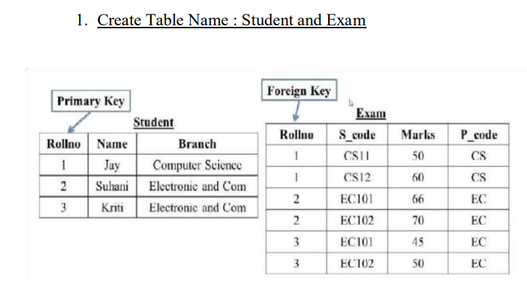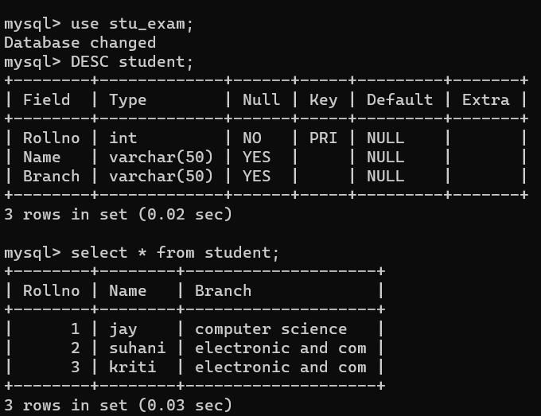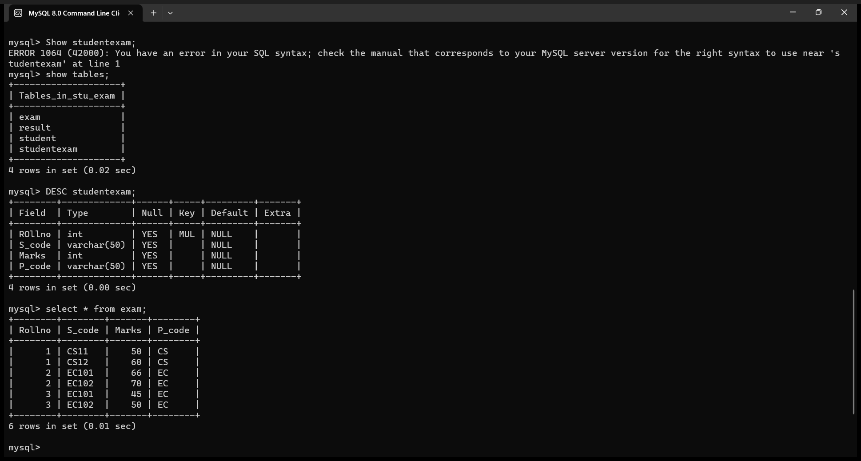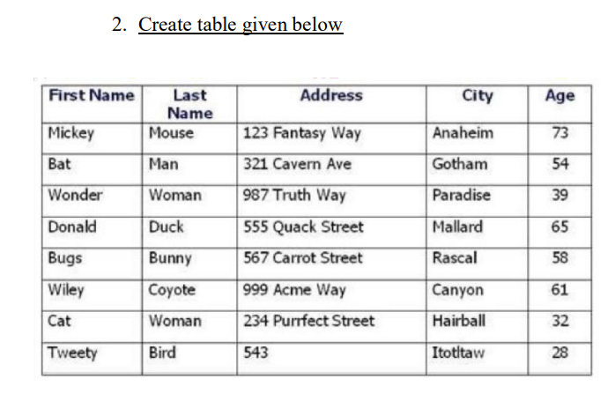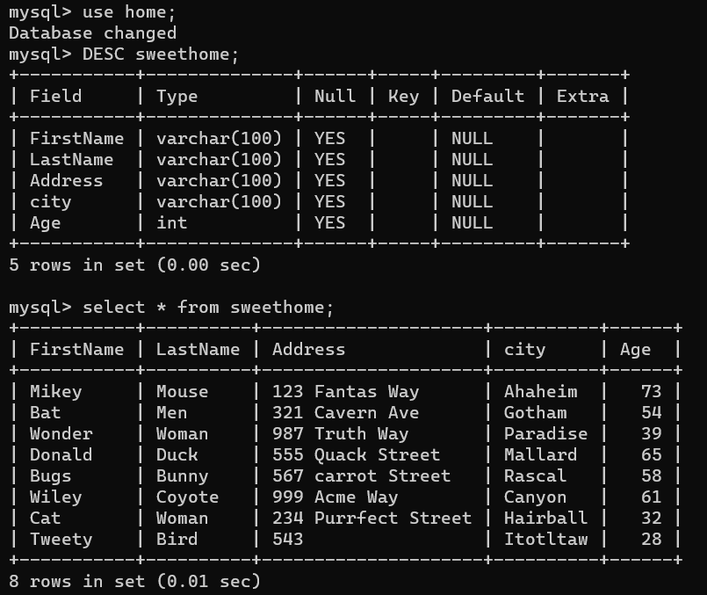

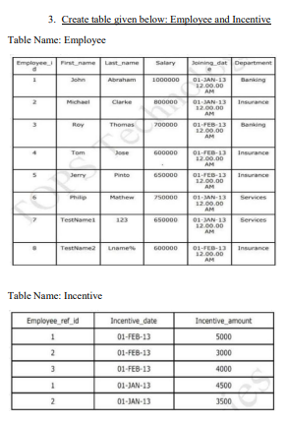

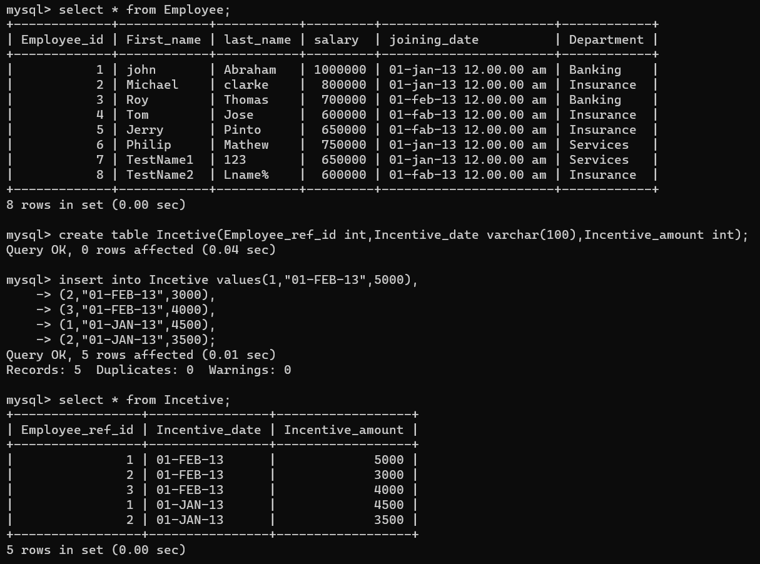

1. **Get First_Name from employee table using Tom name “Employee Name”.**

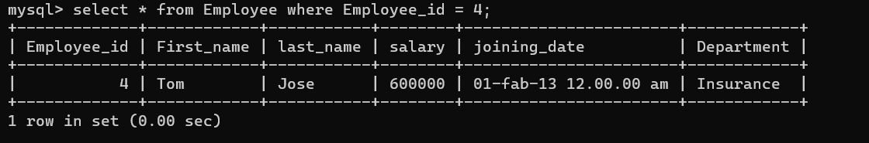

1. **Get FIRST_NAME, Joining Date, and Salary from employee table.**

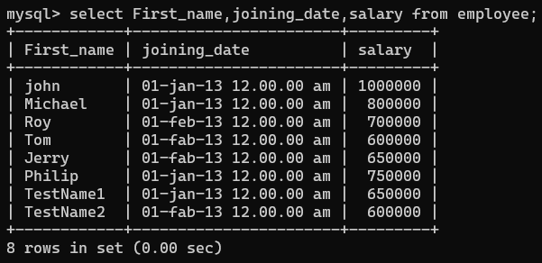

1. **Get all employee details from the employee table order by First_Name Ascending and Salary descending?**

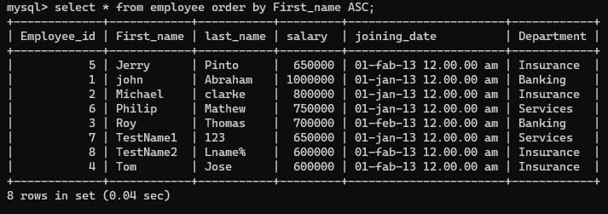

1. **Get employee details from employee table whose first name contains ‘J’.**

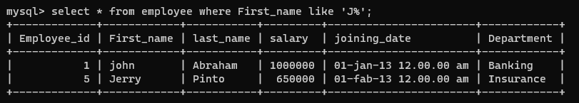

1. **Get department wise maximum salary from employee table order by salary ascending?**



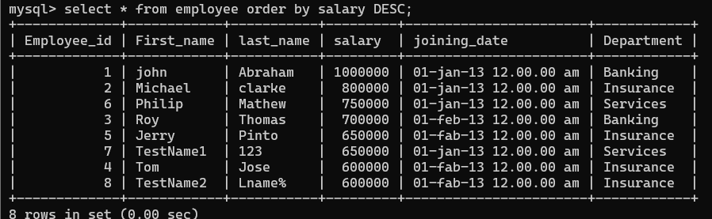

1. **Select first_name, incentive amount from employee and incentives table for those employees who have incentives and incentive amount greater than 3000**

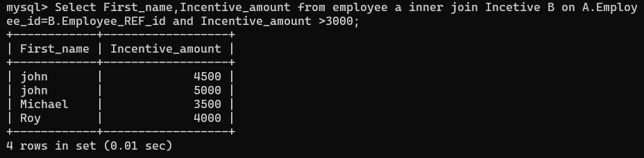

1. **Create After Insert trigger on Employee table which insert records in view table**

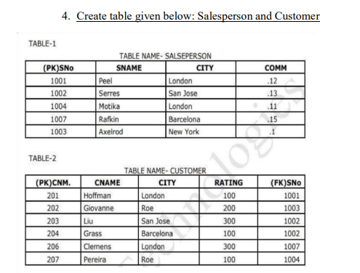

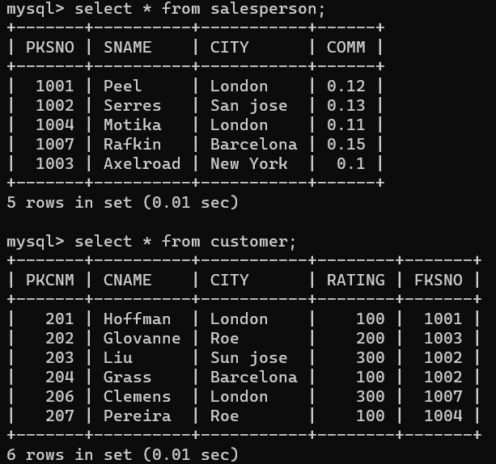

1. **All orders for more than $1000.**

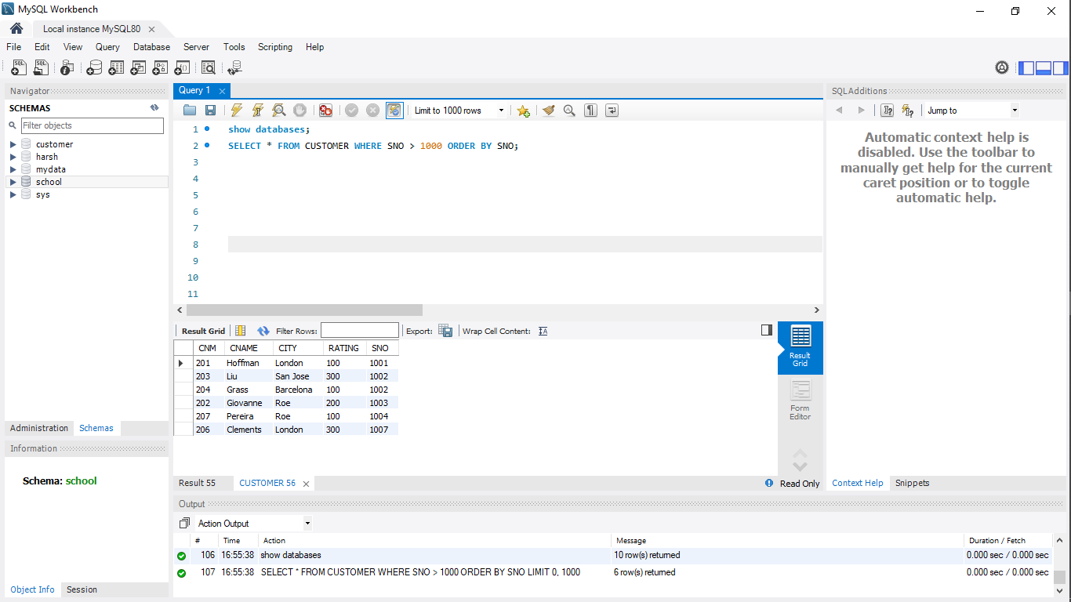

1. **Names and cities of all salespeople in London with commission above 0.12**

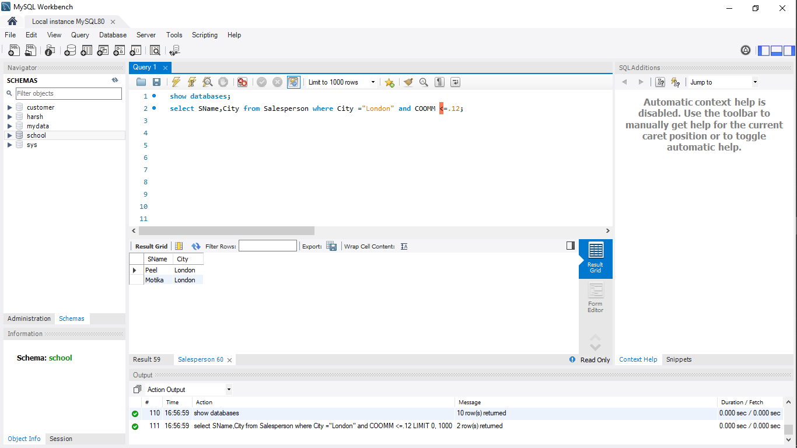

**c) All salespeople either in Barcelona or in London**

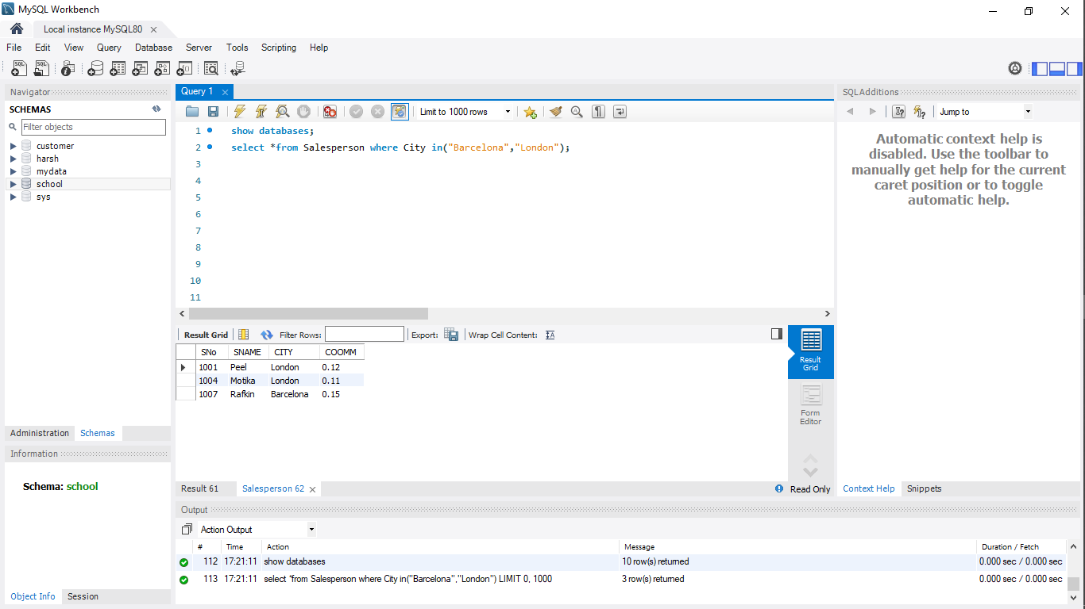

**d) All salespeople with commission between 0.10 and 0.12. (Boundary values should be excluded).**

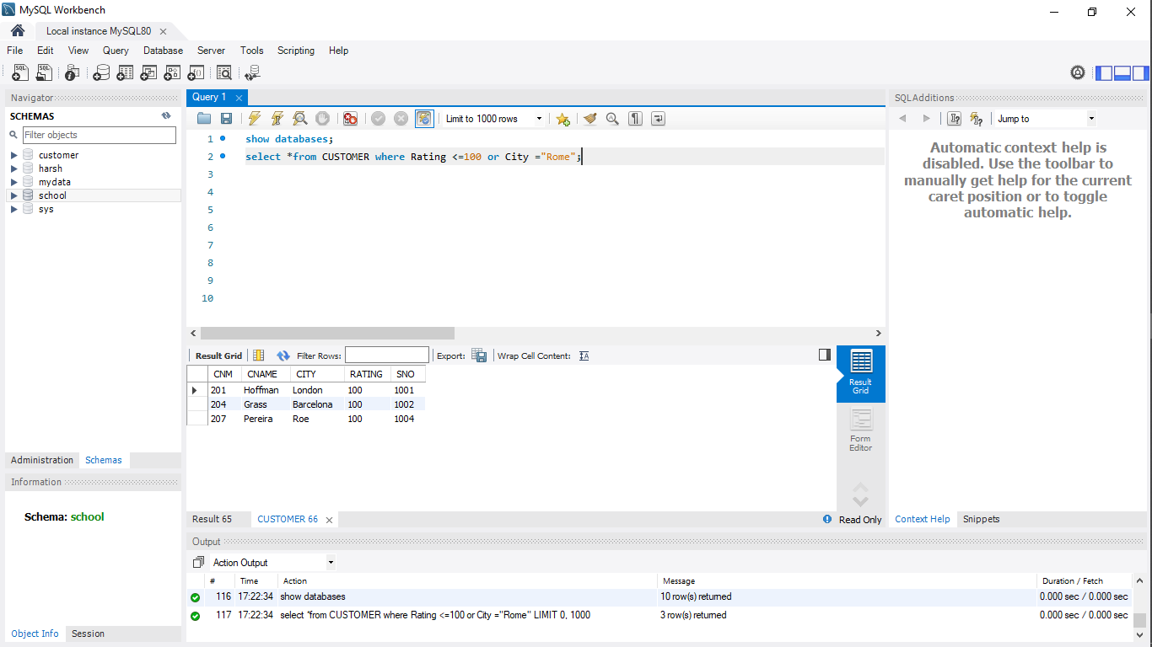

**e) All customers excluding those with rating <= 100 unless they are located in Rome**

